Broker Direct Plc

* * AUCTION RESULT – 18 AUGUST 2023 * *

In the auction that closed at 1pm on 18th August 2023, 7,075 shares traded at 21 pence per share.

The final order book is shown below:

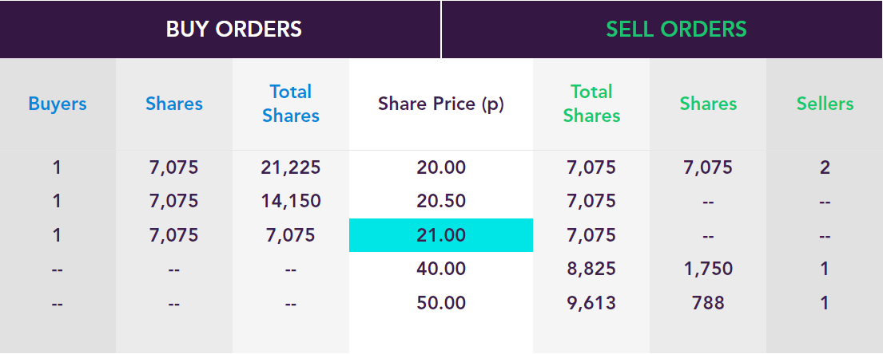

PLEASE DIRECT ANY QUERIES TO ASSET MATCH

TEL: 020 7248 2788

